Report on

Publication of Wall Magazine

Organised by

The Department of English, Mugberia Gangadhar Mahavidyalaya

Date: 15/03/2022

Venue: Shakespeare Hall, Mugberia Gangadhar Mahavidyalaya

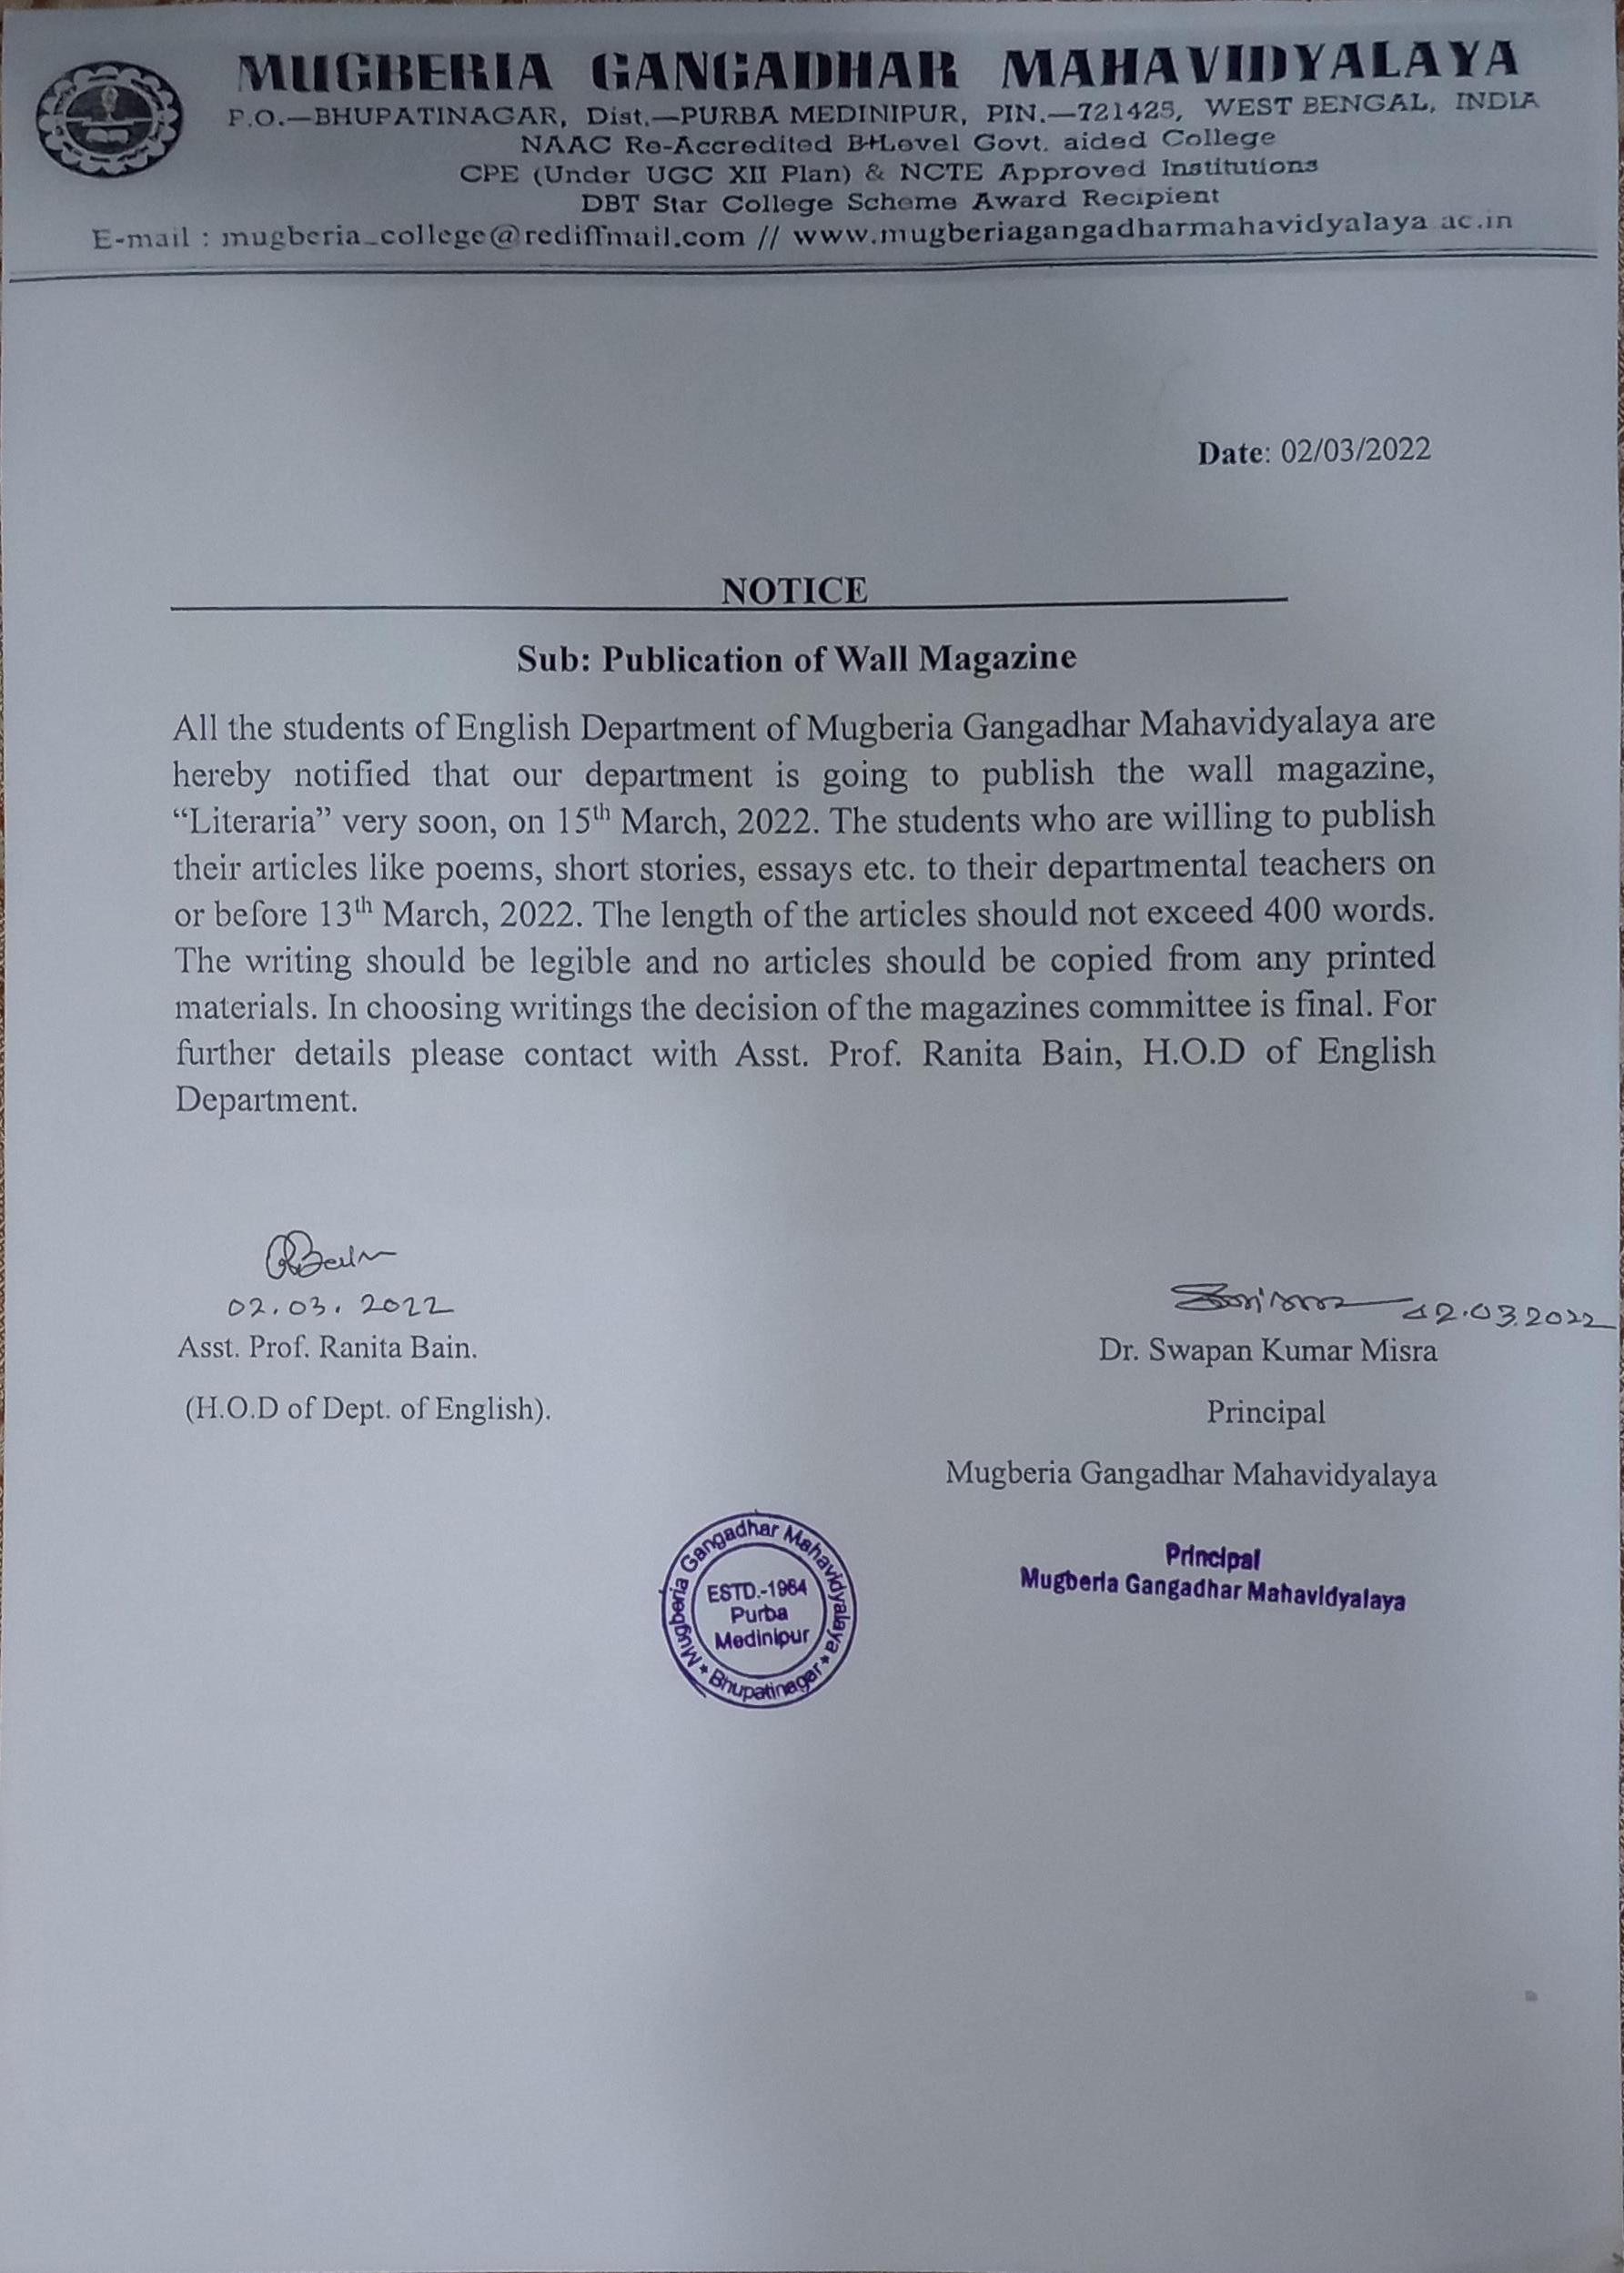

Mugberia Gangadhar Mahavidyalaya
Mugberia, purba Medinipur
Publication of wall magazine
“Literaria”

Face is the index of mind. Similarly, wall magazine is a showcase of students’ creativity. Students can display their artistic works, any piece of interesting and informative news or anything they want to share with their fellow students in the wall magazine named “Literaria”.
The wall magazine has tremendous power to enable us in encompassing not only the present -day curriculum’s non-scholastic aspect but also has its emphasis on the development of learners.
Mugberia Gangadhar Mahavidyalaya has laid an effort upon the development of all possible non-scholastic aspects. As a result of which the wall magazine is published every year in collaborative attempt of all faculty members under the guidance of Prof. Ranita Bain, H.O.D of department of English. Respected Principal Sir Dr. Swapan Kumar Mishra is our icon to encourage all students to cultivate such innovative programmes.

Vision:
• To build a systematic mental state among the learners.
• To constantly endeavour in the clarity of handwriting and them conscious regarding the spellings.
• To draw the learners’ interest towards their artistic and creative works.
• To enable them in building co-operative and collaborative learning situation.
• To inspire the learners by their writings and drawings.

Mission:
• To provide opportunity to the students for self-expression in written form.
• To cultivate and develop in students literary taste and study habits.

Programme schedule:
• Our respectable Principal Sir inaugurated the programme by delivering the inspiring speech and uncovering the curtain in presence of all faculty teachers of English department along with another departmental teachers and nearly 100 students of English department.
• Some students kept their speech from their writings.
• After all, Prof. Ranita Bain bade a lot of thanks to all participants for their co-operation.

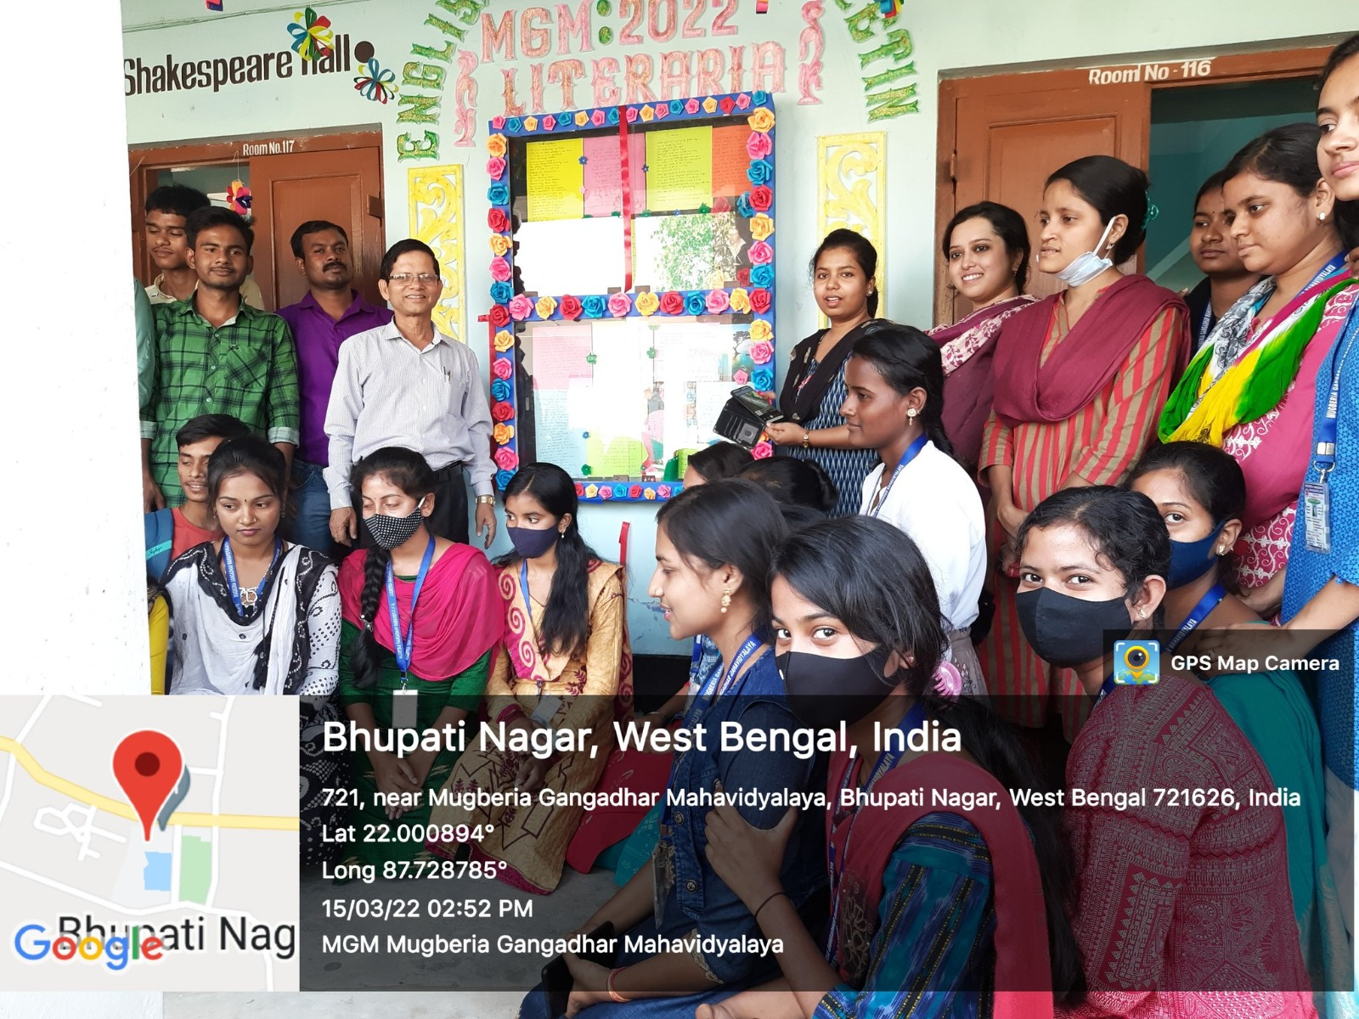
https://twitter.com/MugberiaM/status/1504088165287862275/photo/4
https://twitter.com/MugberiaM/status/1504086989196623878/photo/4
